Home / About Page

Tagline
Amplifying voices. Building brands. Telling stories that connect.

Headshot Alt Text
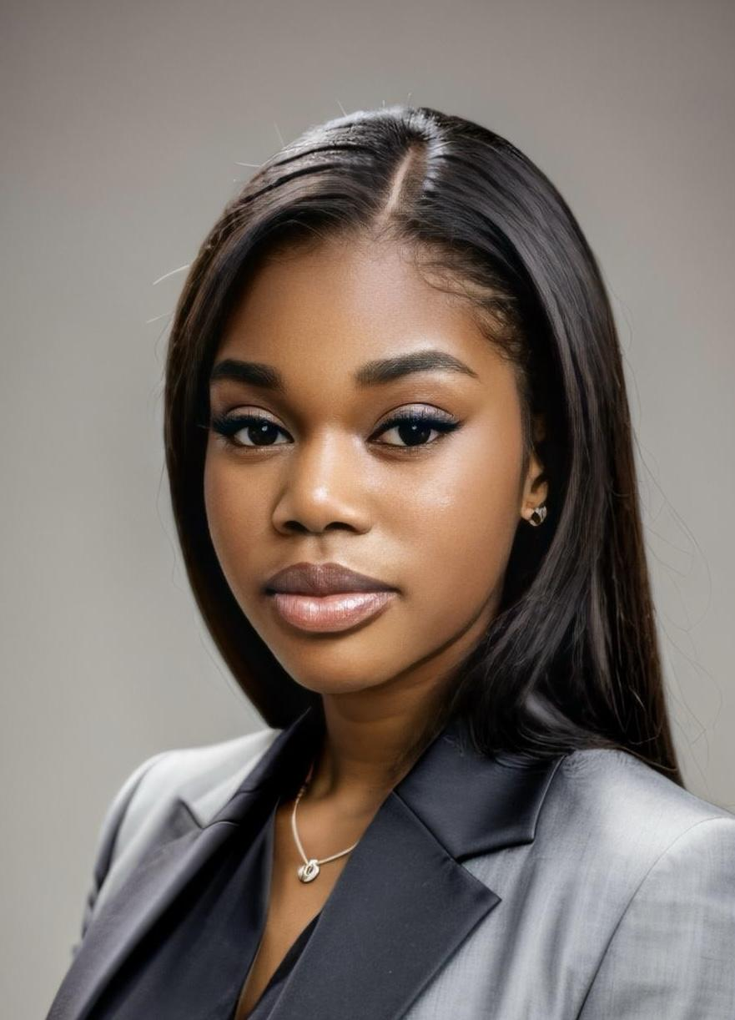

Short Bio (Final Version – Professional & Personal Blend)
Hi — I’m Regina Kadima, a PR & Media Professional with hands-on experience in campaign strategy, media relations, and digital content production. I’ve led DEI-focused initiatives, developed creative pitches for lifestyle brands, and supported on-air teams with news writing and production. I’m passionate about helping brands tell authentic stories that inspire connection and growth.

Quick Profile Details
- 📍 Location: Dallas, TX (open to opportunities in Chicago & beyond)
- 💼 Roles: PR & Media Professional · Brand Communications · Content & Production
- ✨ Strengths: social media management, media pitching, social strategy, VOSOT/VO writing, campaign coordination

Contact Links
- 📧 Email: regina.kadima@example.com
- 🔗 LinkedIn: linkedin.com/in/regina-kadima
- 📄 Resume (PDF): Download Resume

Resume
Purpose: Provide a quick overview of your skills, education, and experience.
Include:
- Your current resume (formatted cleanly for web)
- A link to download it as a PDF
- Optional “Skills Snapshot” sidebar:
  - Media writing (press releases, social captions)
  - Public relations planning
  - Brand storytelling
  - Social media management
  - Adobe Creative Suite / Canva / Google Workspace

Campaigns / Projects
Purpose: Demonstrate strategic thinking and project execution.
Include:
- Civic Engagement Project: “Bring Back DEI at Work”

- SKIMS Ghost Pitch — treat as a PR case study (background, strategy, media list idea, mock pitch, results)
- Black Academics Organization Media Work — event coverage, graphics, or social posts
- Christian TV Internship — production assistance, media coordination, or social coverage
💡 Each project should include:
- Objective or challenge
- Your role
- Strategy or approach
- Outcome or impact
- Visuals (mockups, screenshots, photos)

